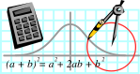  Rossmoyne SHS  Mathematics  Department | MATHEMATICS SPECIALIST 3AB | Semester 1 2010  EXAMINATION

NAME:
TEACHER: Mrs. Benko Mr. Longley
Ms. Robinson

Section Two:
Calculator-assumed

Time allowed for this section
Reading time before commencing work: 10 minutes
Working time for this section: 100 minutes

Materials required/recommended for this section

To be provided by the supervisor
This Question/Answer Booklet
Formula Sheet (retained from Section One)

To be provided by the candidate
Standard items: pens, pencils, pencil sharpener, eraser, correction fluid, ruler, highlighters

Special items: drawing instruments, templates, notes on two unfolded sheets of A4 paper, and up to three calculators satisfying the conditions set by the Curriculum Council for this examination

Important note to candidates
No other items may be taken into the examination room. It is your responsibility to ensure that you do not have any unauthorised notes or other items of a non-personal nature in the examination room. If you have any unauthorised material with you, hand it to the supervisor before reading any further.
Structure of this paper

Section | Number of questions available | Number of questions to be answered | Suggested working time  (minutes) | Marks  available
Section One:  Calculator-free | 8 | 8 | 50 | 40
Section Two:  Calculator-assumed | 14 | 14 | 100 | 80
 |  |  |  | 120

Instructions to candidates

- The rules for the conduct of Western Australian external examinations are detailed in the Year 12 Information Handbook 2010. Sitting this examination implies that you agree to abide by these rules.

2. Answer the questions according to the following instructions.

Section Two: Write answers in this Question/Answer Booklet. All questions should be answered.
Show all your working clearly. Your working should be in sufficient detail to allow your answers to be checked readily and for marks to be awarded for reasoning. Incorrect answers given without supporting reasoning cannot be allocated any marks. For any question or part question worth more than two marks, valid working or justification is required to receive full marks. If you repeat an answer to any question, ensure that you cancel the answer you do not wish to have marked.
It is recommended that you do not use pencil except in diagrams.

3. You must be careful to confine your responses to the specific questions asked and to follow any instructions that are specific to a particular question.

- Spare pages are included at the end of this booklet. They can be used for planning your responses and/or as additional space if required to continue an answer.
  - Planning: If you use the spare pages for planning, indicate this clearly at the top of the page.
  - Continuing an answer: If you need to use the space to continue an answer, indicate in the original answer space where the answer is continued, i.e. give the page number. Fill in the number of the question(s) that you are continuing to answer at the top of the page.

QUESTION | MARKS AVAILABLE | STUDENT MARK
1 | 4
2 | 5
3 | 4
4 | 7
5 | 5
6 | 7
7 | 8
8 | 7
9 | 4
10 | 4
11 | 4
12 | 6
13 | 8
14 | 7
TOTAL | 80

Section Two (calculator assumed)
Working time: 100 minutes.
Available marks: 80 marks

Question 1 [4 marks]

a) On the same set of axes draw the graphs of 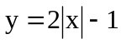 and 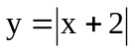
[2]
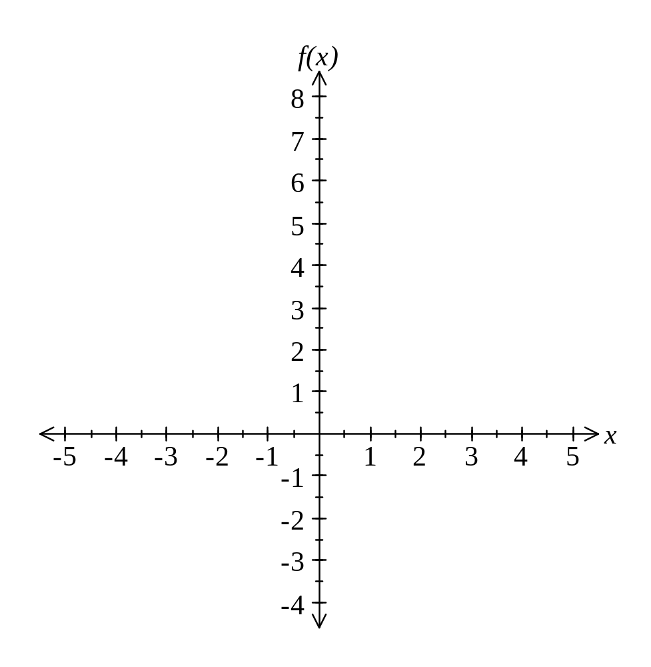
- From your graphs obtain values of 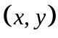 which satisfy both equations.
[2]
Question 2 [5 marks]
At 3 pm, Alex is sailing due east at 30km/hr. He observes a reef on a bearing of 065° at a distance of 20 km. When will Alex be 12 km or less from the reef if he continues on this course?(Give answer correct to nearest minute).

Question 3. [4 marks]
A pyramid 16cm high has a square base with sides of 12cm.The apex A of the pyramid is directly above the centre C of the base PQRS.
- Calculate the length of its sloping edges.
[2]
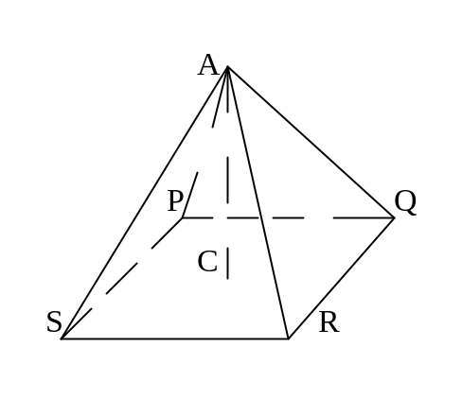

- Calculate the angle made by the sloping edge with the base.
[1]

- Calculate the angle made by a sloping face of the pyramid with its base.
[1]

Question.4 [7 marks]
In still air Brad can fly his plane at a steady 350 km/hr. He needs to fly 810 km, to his holiday destination which is in a direction of 060from his base.
The wind is blowing at 40 km/hr from 140.

(a) In what direction must Brad fly to go directly to his holiday spot?
[5]

(b) How long does the trip take?
[2]

Question 5 [5 marks]

It looks as though the boat called “Hope” is still in trouble and is being dragged towards the same East-West reef by currents moving due South with a force of 3500N. Yet again, the rescue vessels called “Hero” and “Heroine” are trying to prevent a disaster by attaching rescue lines to the boat called “Hope”.
Hero exerts a force of 2200N on a bearing of 050°and Heroine exerts a force of 2000N on a bearing of 340°.
Demonstrate the use of component vectors to determine the fate of the boat “Hope”.
- Find the resultant force exerted on Hope. (in component form)
[3]

- Its magnitude and direction.
[2]
Question 6 [7 marks]
(a) If the vector a has a polar angle of 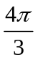 and a magnitude of 6 metres, write a in the form ai +bj
[2]

(b) If a = -3i + 4j, b = i + 2j and c = 2i – j, determine each of the following

(i) A vector parallel to c and twice as long
[1]

(ii) The magnitude of a
[1]

(iii) The unit vector in the same direction as c
[1]

(iv) A vector parallel to a with three times the magnitude of c
[2]

Question.7 [8marks]

Airports A and B are such that 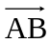=(500i+1200j) km. An aircraft is to be flown directly from A to B.
In still air the aircraft can maintain a steady speed of 425 km/h.
There is a wind blowing with velocity (24i+7j) km/h.
Find:
a) The velocity vector, in the form (ai+bj) km/h. the pilot should set so that this velocity, together with the wind causes the plane to travel directly from A to B? Give your answer correct to 2 decimal places.
[6]

b) The time taken to travel from A to B.
[2]

Question 8 [7 marks]

Find the area common to two circles which have their centres 15m apart.
One of the circles has an 8m radius and the other has a radius of 12m.

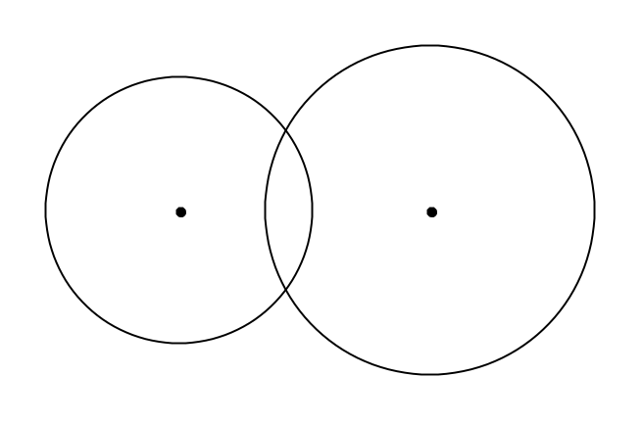

Question.9 [4marks]
The population of a town grows according to the rule 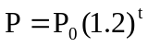 where is in years
- Find the percentage increase in the population per year.
[1]

- How long does it take for the population to triple?
[3]

Question 10 [4 marks]
Given that r= 4i – 5j and the position vector of C is 5i + 6j, find how far and in what direction is A from O.

Question 11 [4 marks]

The velocities (in m/s), of three moving objects P, Q ,R are 5i + 4j, -i +7j and 9i - 2j respectively.
- Find the velocity of P relative to Q.
[1]

- In what direction and with what speed is Q moving relative to R.
[3]

Question 12 [6 marks]

Given that f(x)=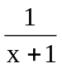, find:
- f(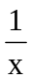) in simplified form
[1]

- x such that f(x)= f()
[2]

- The natural domain and range of g given that g(x)=[f(x)]
[3]

Question 13 [8 marks]

Given that f(x) = x-1, g(x)= , find the largest possible domain for
- f(x) so that g[f(x)] is a function.
[2]

- g(x) so that f[g(x)] is a function.
[2]

- Using the restricted domain, state the rule, domain and range for each composite function.
[4]

Question 14 [7 marks]

For the function f(x)= (x+4),
- Explain why f(x) cannot have an inverse function for its natural domain.
[2]

- Find the largest possible domain for f(x) consisting only of negative numbers so that f(x) has an inverse.
[1]

- For the domain in (b), find the rule for the inverse of f(x).
[2]

- For the domain in (b), find the domain and range for the inverse of f(x).
[2]

